# **Backend code using python:**

Gernerating run chart using matplot lib

import matplotlib.pyplot as plt

import numpy as np

# Sample data

days = np.arange(1, 32)

strength = np.random.randint(35, 65, size=31)

hardness = np.random.randint(90, 120, size=31)

# Calculate mean, UCL, and LCL for strength

mean_strength = np.mean(strength)

ucl_strength = mean_strength + 3 * np.std(strength)

lcl_strength = mean_strength - 3 * np.std(strength)

# Calculate mean, UCL, and LCL for hardness

mean_hardness = np.mean(hardness)

ucl_hardness = mean_hardness + 3 * np.std(hardness)

lcl_hardness = mean_hardness - 3 * np.std(hardness)

# Plotting the data

plt.figure(figsize=(12, 6))

# Plot strength

plt.plot(days, strength, 'bo-', label='Strength')

plt.axhline(y=mean_strength, color='b', linestyle='--', label='Mean Strength')

plt.axhline(y=ucl_strength, color='b', linestyle=':', label='UCL Strength')

plt.axhline(y=lcl_strength, color='b', linestyle=':', label='LCL Strength')

# Plot hardness

plt.plot(days, hardness, 'gs-', label='Hardness')

plt.axhline(y=mean_hardness, color='g', linestyle='--', label='Mean Hardness')

plt.axhline(y=ucl_hardness, color='g', linestyle=':', label='UCL Hardness')

plt.axhline(y=lcl_hardness, color='g', linestyle=':', label='LCL Hardness')

# Customizing the plot

plt.title('Run Chart for Strength and Hardness Over Time')

plt.xlabel('Time (Days)')

plt.ylabel('Metrics')

plt.legend()

plt.grid(True)

# Show the plot

plt.show()

**output generated by above code:**

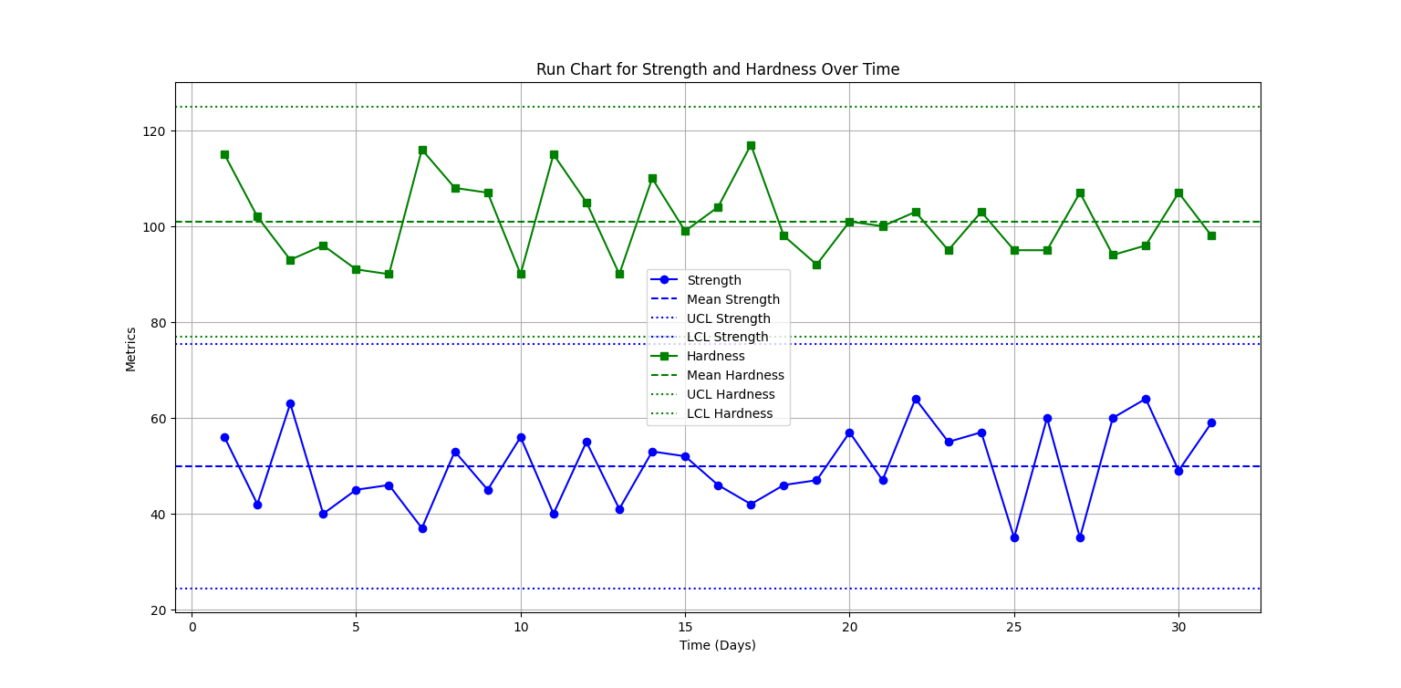

**Import to excel using flask:**